**WEEK -4**

**Day -1 : 05 February 2024**

**Userpincode.html**

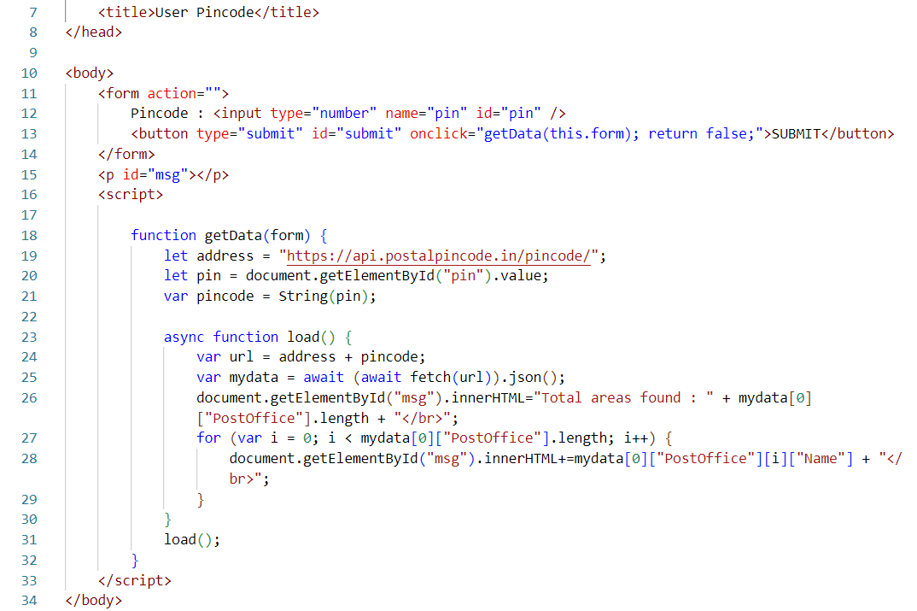

**Output :**

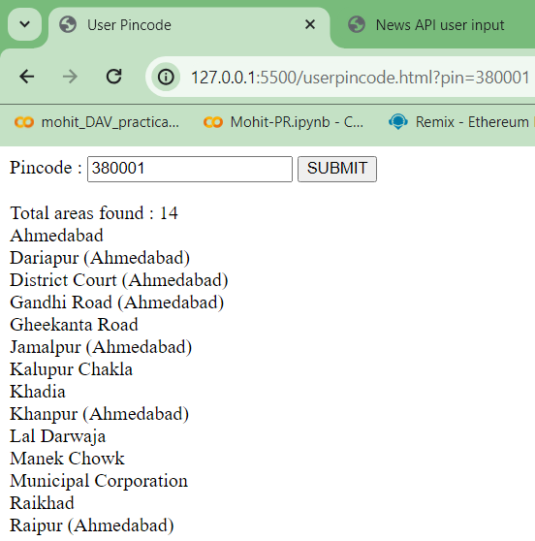

**Newsapi.html**

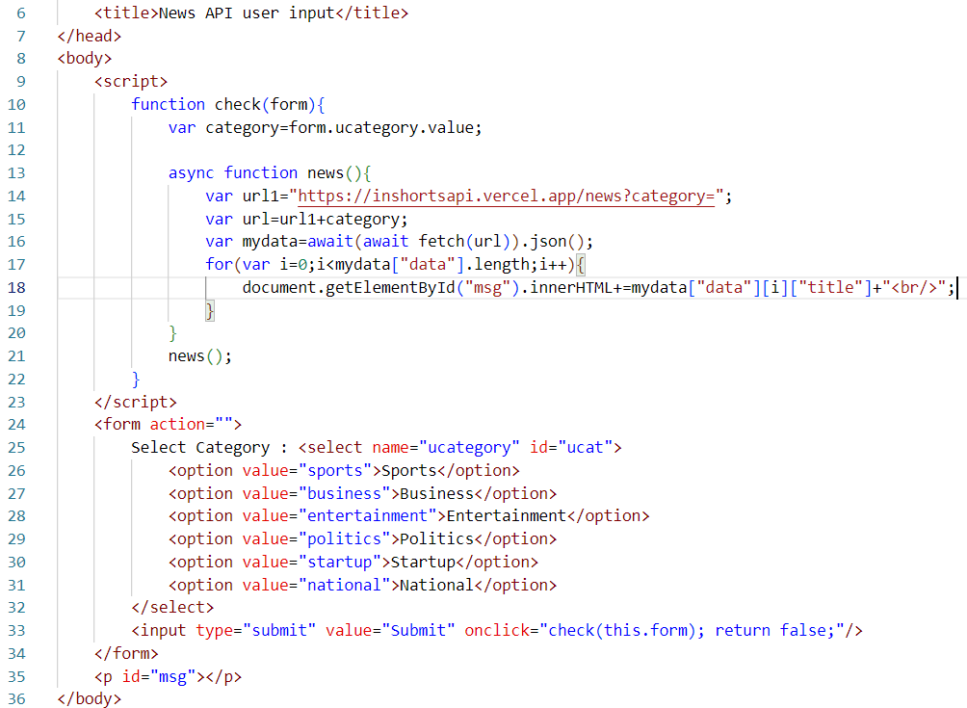

**Output :**

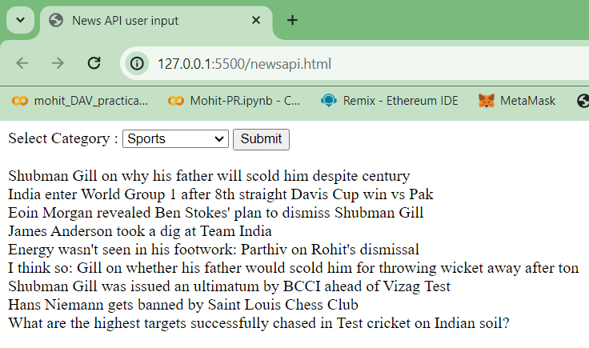

**Wordmeaning.html**

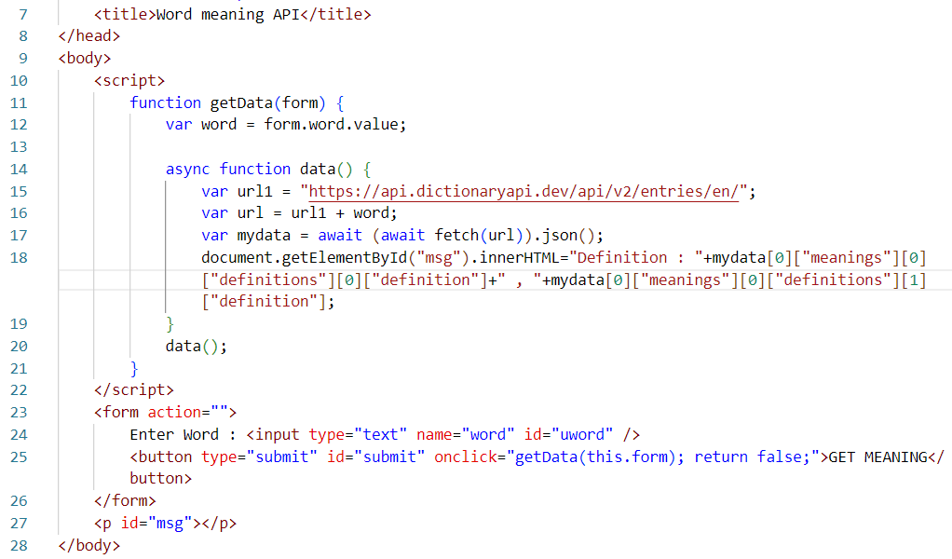

**Output :**

